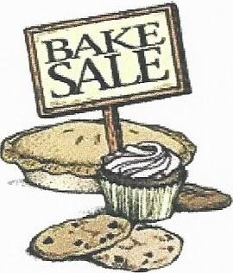
Wabash County Health Department
Best Practices for Bake Sales /
Frequently Asked Questions

For more information, please contact: Marina Sample, LEHP
Wabash County Health Department 618-263-3873 ext. 233

IS A PERMIT NEEDED FOR A BAKE SALE? No, you do not need a permit for occasional bake sales as fundraisers. The Health Dept does not regulate Bake Sales or Fundraisers.
WHAT TYPE OF ITEMS CAN BE SOLD? Baked goods, such as, but not limited to, breads, cookies, cakes, pies and pastries. Only high-acid fruit pies that use the following fruits are allowed: apple, apricot, grape, peach, plum, quince, orange, nectarine, tangerine, blackberry, raspberry, boysenberry, cherry, cranberry, strawberry, red currants or a combination of these fruits.
WHAT ITEMS ARE PROHIBITED? Pumpkin, sweet potato, custard or cream pies and pastries, cheesecake, meringues or other potentially hazardous fillings or toppings.
HOW SHOULD THE BAKED GOODS BE DISPLAYED? Individually pre-wrap them (plastic wrap, plastic bags, etc.). Don't have open foods on tables; everything should be packaged.
SHOULD THE ITEMS BE LABELED, AND IF SO, WHAT SHOULD BE ON THE LABELS? Best Practice (though not required) is to label items with the baker's name and address, the common name of the food product, ingredients, the date it was produced, and allergen labeling.
BEST PRACTICE SAMPLE LABEL:

Cinnamon Rolls -Net Wt. 12 oz
Flour (wheat flour, niacin, reduced iron, thiamine, mononitrate, riboflavin and folic acid), sugar, butter, eggs, mi1k, yeast, cinnamon and salt
Contains: wheat, eggs, milk
John Dough
123 Cookie Street, Cak:esville, IL 60000
Production Date: 01/01/2012 This product was produced in a home kitchen not subject to public health inspection that may also process common food allergens.
Major allergens in baked goods include peanuts (peanut butter), eggs, wheat, soybeans, milk and milk products (e.g. butter, buttermilk), and tree nuts (e.g. almonds, pecans, walnuts and cashews).
If a packaged brownie, cake, cookie mix, or pie crust is used, you could include a copy of the information panel from the box as well as any added ingredients like eggs, oil, nuts, etc.
It is a good idea for the event organizer to retain a list of bakers' contact information.
Signage stating "Products produced in a home kitchen not subject to Health Department inspection" should be on display in sale area.
Use common sense: no eating, drinking, or smoking in the sales area.
Wash hands often and especially after using restrooms.
Display foods on clean counters and keep the sale area clean.

