When Suicide intent or risk is detected early, lives can be saved. It’s important to know the signs that someone may be at risk for suicide.
- Suicide is the 10th leading cause of death in the United States.
- One Suicide occurs on average every 13.3 minutes in the U.S.
- Suicide is the 2nd leading cause of death among 15-24 year olds.
- It is estimated that five million Americans have attempted to kill themselves.
- More people in the United States die by Suicide each year than by homicide.
Suicide Statistics:
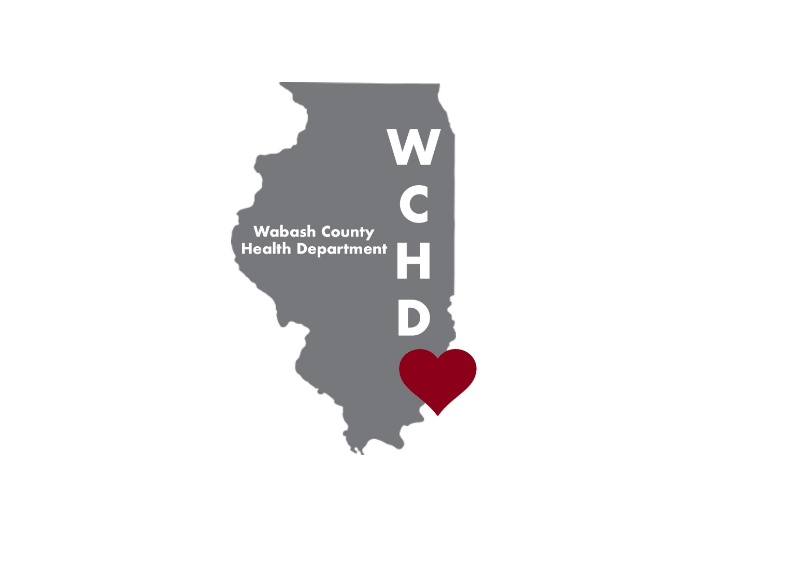

Warning Signs:
- Threatening to hurt or kill oneself or talking about wanting to hurt or kill oneself.
- Looking for ways to kill oneself by seeking access to firearms, available pills or other means.
- Talking or writing about death, dying or suicide when these actions are out of the ordinary.
- Feeling hopeless.
- Feeling rage or uncontrolled anger or seeking revenge.
- Acting reckless or engaging in risky activities-seemingly without thinking.
- Feeling trapped-like there is no way out.
- Increasing alcohol or drug use.
- Withdrawing from friends, family and society.
- Feeling anxious, agitated or unable to sleep or sleeping all the time.
- Experiencing dramatic mood changes.
- Seeing no reason for living or having no sense of purpose in life.
Get Involved

- Be available, show interest and support
- Ask if he/she is thinking about suicide
- Be direct. Talk openly and freely about suicide
- Be willing to listen. Accept the feelings
- Be non-judgmental
- Don’t ask why, offer empathy
- Don’t be sworn to secrecy, offer hope
Seek Help – Talk to Someone!!
A Community Mental Health Agency
A Physician
A Religious Leader
A Crisis Intervention Line
Call 911

For more information, or if you or someone you love is struggling with suicidal thoughts, please contact us.
The Depot Counseling Center
618-263-4970

